CS-23334 FUNDAMENTALS OF DATA SCIENCE
ASHWIN C 240701058

Experiment 12 Date: 16.10.2025

12. Hypothetical using Z-Test

Aim:
To test whether the average weight of a species of birds differs from 150 grams.

Description:
Z test is used to determine if the average weight of the bird population significantly differs from 150 grams by comparing the sample mean to the hypothesized population mean.

Algorithm:
1. Null Hypothesis (H₀): The average weight of the birds is 150 grams.
2. Alternative Hypothesis (H₁): The average weight of the birds is not 150 grams.
3. Sample: Measure the weights of 30 birds randomly selected from the population.
4. Z-Test: Conduct a Z-test to compare the sample mean to 150 grams.
5. Decision Rule: Use a significance level of α = 0.05.

Code With Output:

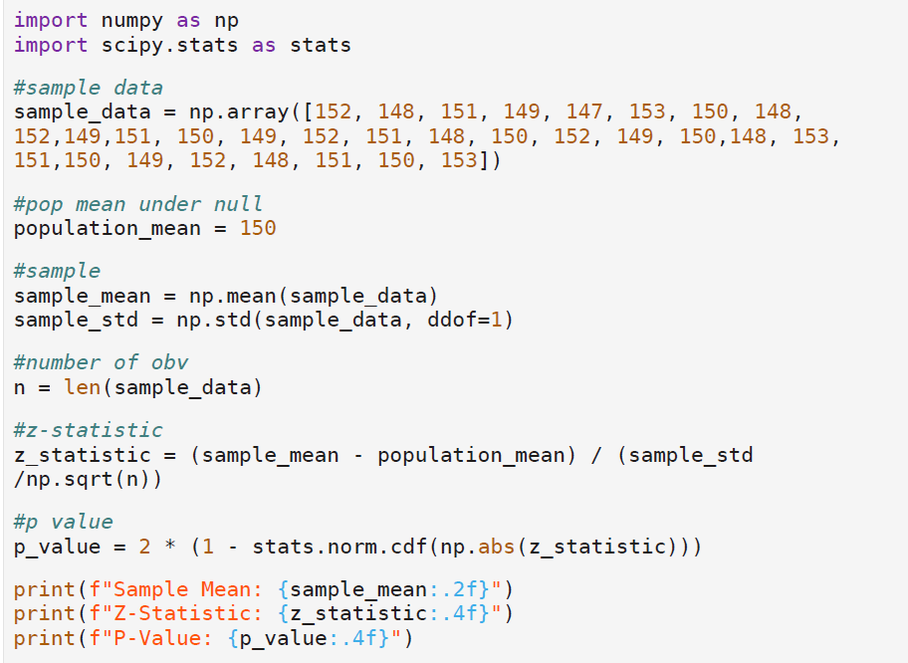

Output:

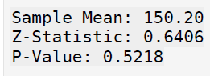

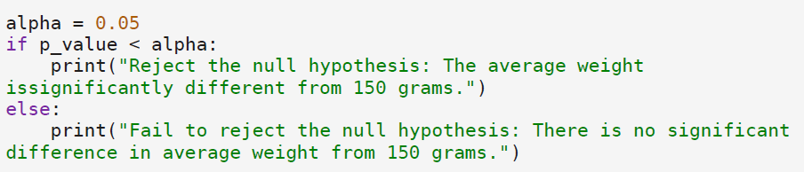

Output:

Result:
Thus, the Python program to test whether the average weight of the bird species differs from 150 grams uses a z test that compares the sample mean to the hypothesized population mean was executed.

